From the customer end take ping report with the site customer wants latency
(for example 8.8.8.8 google DNS)
#ping 8.8.8.8
PING 8.8.8.8 (8.8.8.8): 36 data bytes,
timeout is 1 second
!!!!!!!!!!!!!!!!!!!!
----8.8.8.8 PING Statistics----
20 packets transmitted, 20 packets received, 0.0% packet loss
round-trip min/avg/max/stddev = 112.337/115.417/148.033/7.822 ms
TESTING OF ILL TO UNIVERSITIES UNDER NME PROJECT
Testing at BSNL Premises
- Check the converter is as per the specifications received from NOC.
- Connect the Optical converter (1550 wavelength is MUST) to the GE port.
- Connect laptop/PC to the electrical port of the converter.
- Ensure that the Port is UP after connection. If port is not UP pl check the specifications of the converter as per details received from NOC.
- Configure the IPs for Gateway and PC as per the details received from NOC.
- Ping the Gateway IP and it should be successful. If pinging is not successful please contact NOC on 080-22028984 and verify the configuration.
- Check the browsing using some internet sites.
- Check the speed using FTP. For single session the speed should be around 4-8Mbps.

Testing at University End
- Check the Router/Switch available at University is having provision for Optical connectivity.
- If direct optical connectivity is not possible then connect the Router/Switch of the university through the Optical converter.
- Please ensure that the connectivity is put through the firewall.
- Check the speed through the LAN using multiple sessions as BW depends on the load. The combined bandwidth of all the systems and sessions only should be taken into account for calculating the total bandwidth.

SPEED TEST THROUGH FTP
( FTP server IPs : 218.248.255.137 ( Bangalore ); 218.248.255.147 ( Chennai ) )
Go to command prompt:
Do ftp and login with the credentials as shown below
>ftp 218.248.255.137
User name: bsnl123
Password : bsnl123

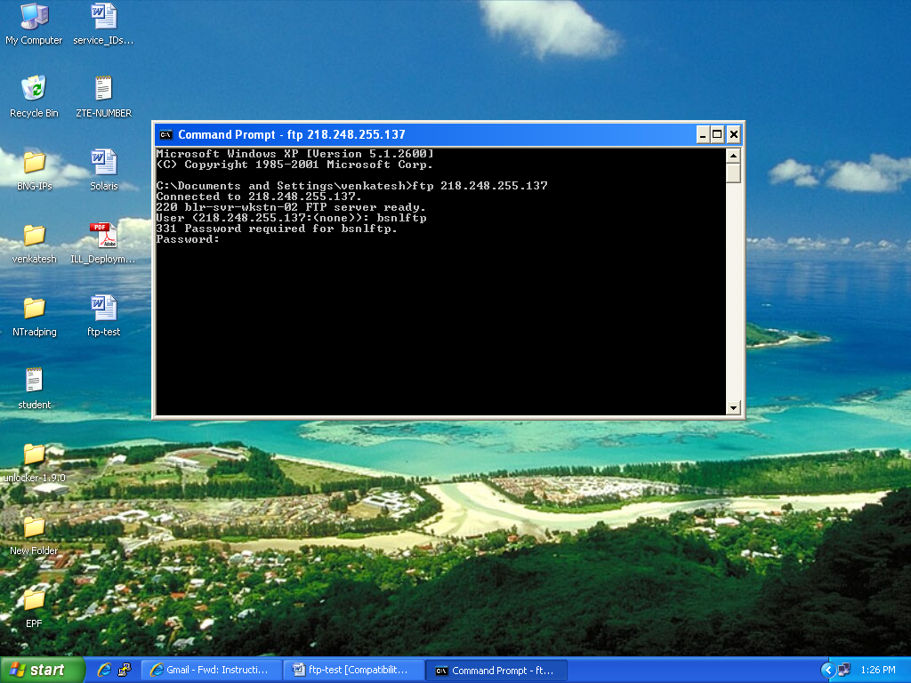

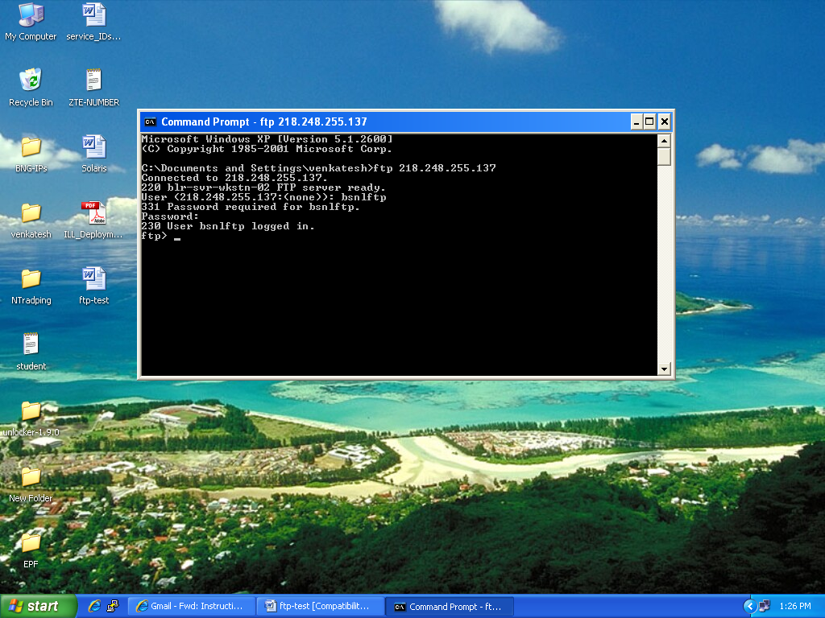

After logging in , please give below three commands , and you will see list of files available in the ftp server at the end of third command
ftp> bin
ftp>hash
ftp>ls –ls
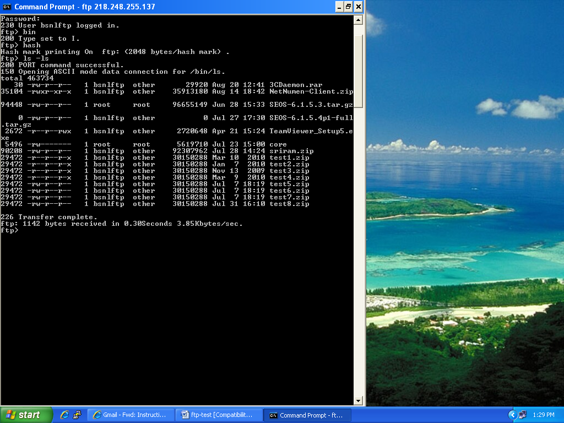
Select any file from the list and download as shown below
( here the file selected is test1.zip)
FTP> mget test1.zip ( enter )
give “y” and (enter)
you will see a screen like this while downloading
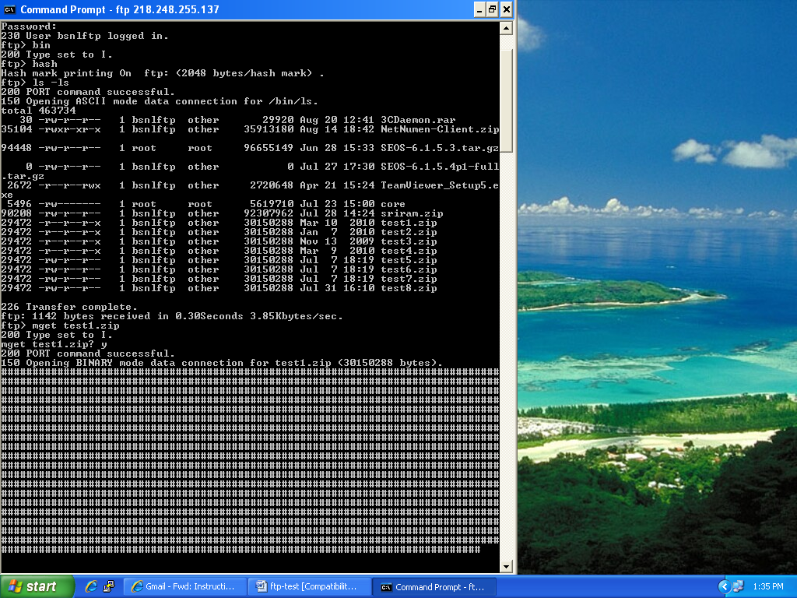

After downloading the file, you will see result as below
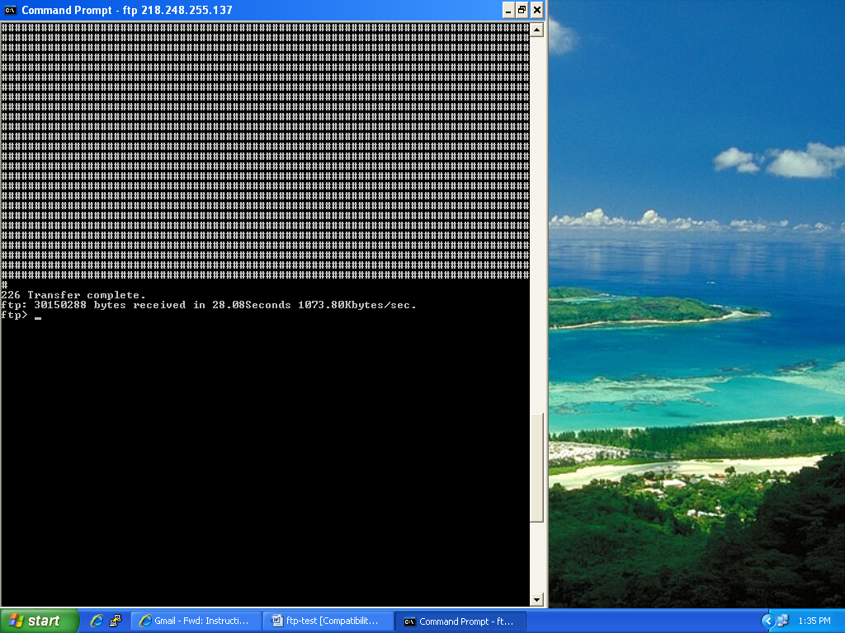
From the result : the downloading speed is : 1073.80Kbytes/sec
Which is equal to : 8.389 Mbps ( (1073.80 *8) / 1024)
---- end --

